Forgot Jenkins username and Password …How to Reset

* First Open Jenkins server Install vm
* 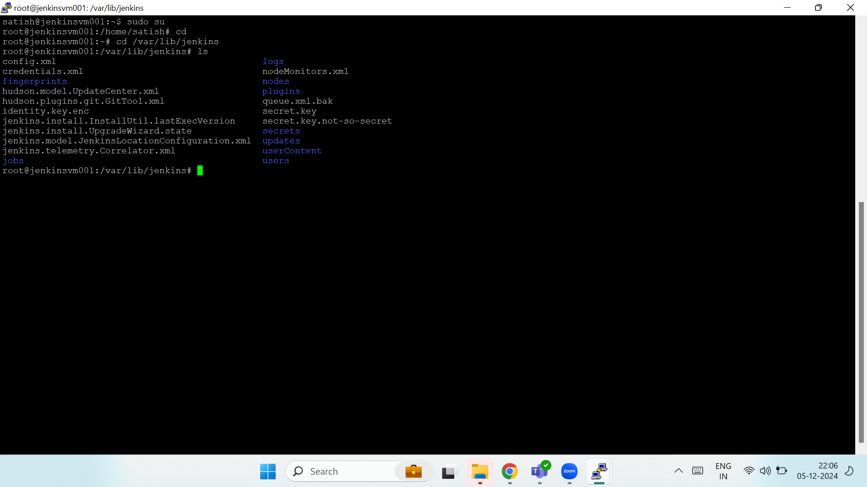
* Go to cd /var/lib/Jenkins
* Go to Config.xml > open file >go to use security TRUE change to FALSE
* 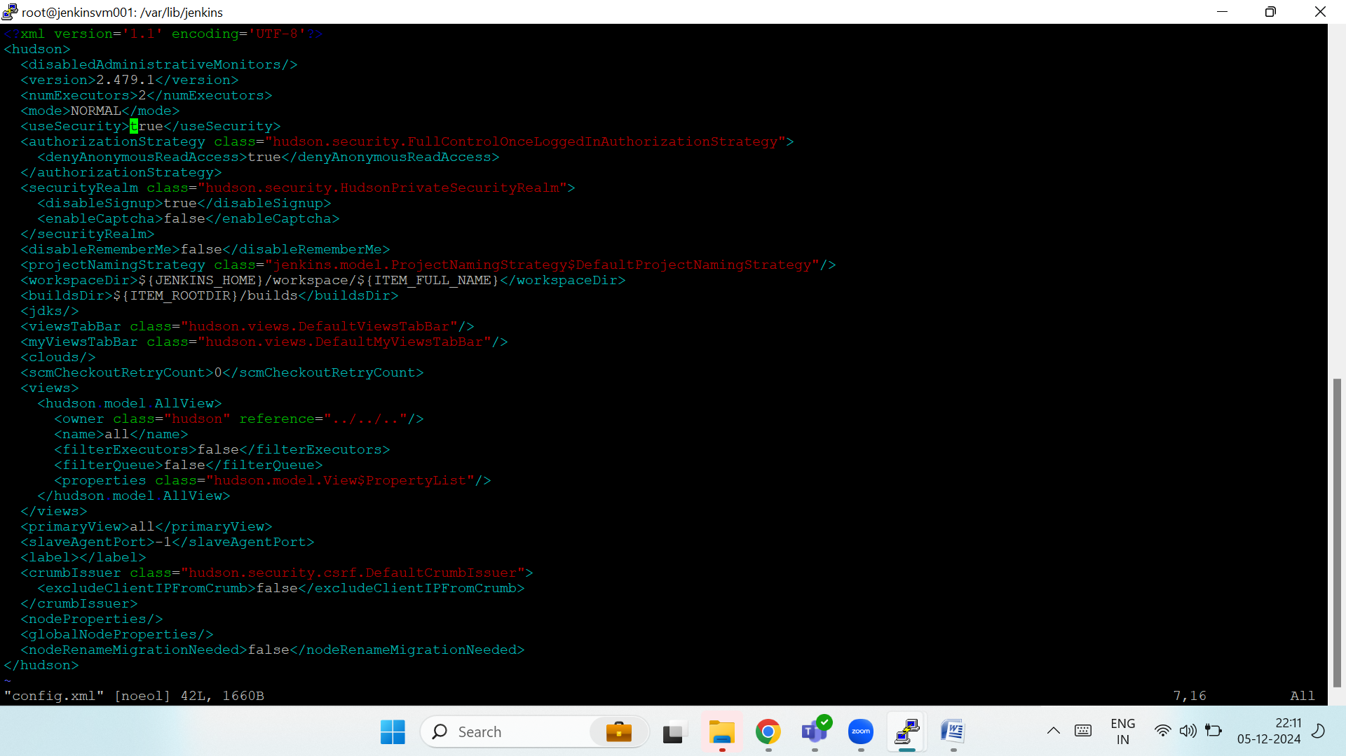
* Save and exit
* Systemctl restart Jenkins
* open browser >open Jenkins server>
* Open the server with out user name and password
* How to create Username and password
* Go to Manage Jenkins
* 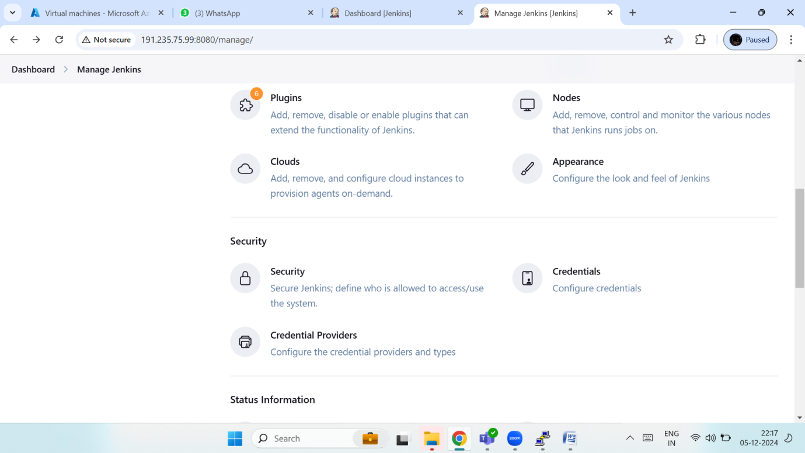
* Go to Security
* Just Select Jenkins own user database
* 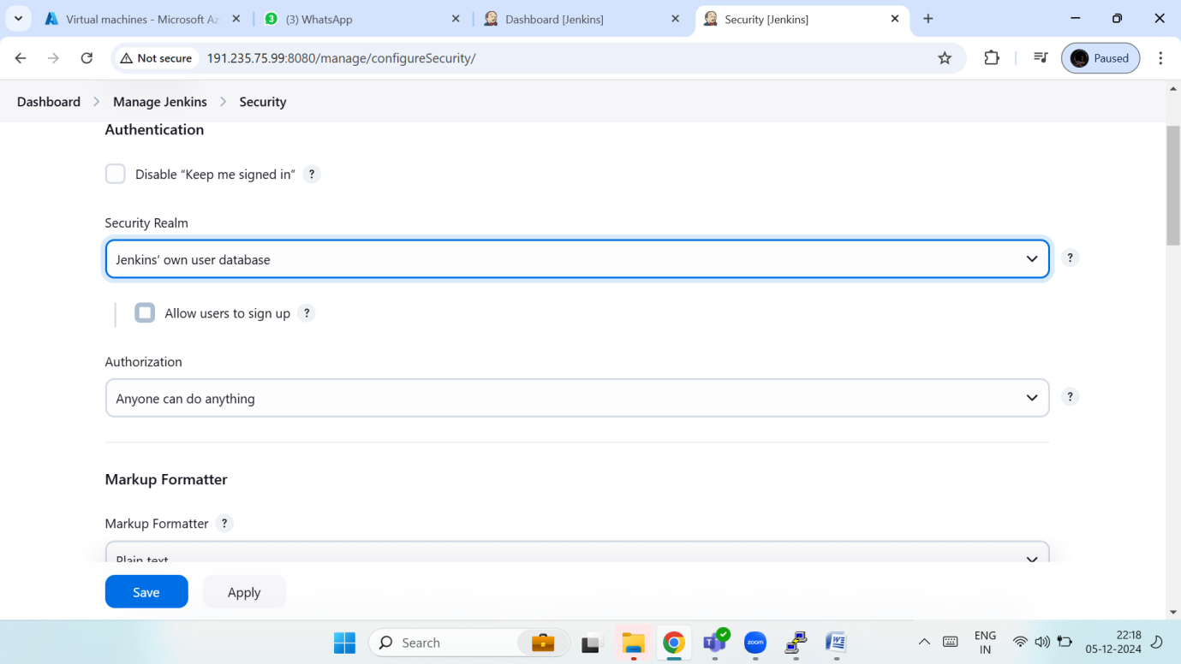
* Go to manage Jenkins
* 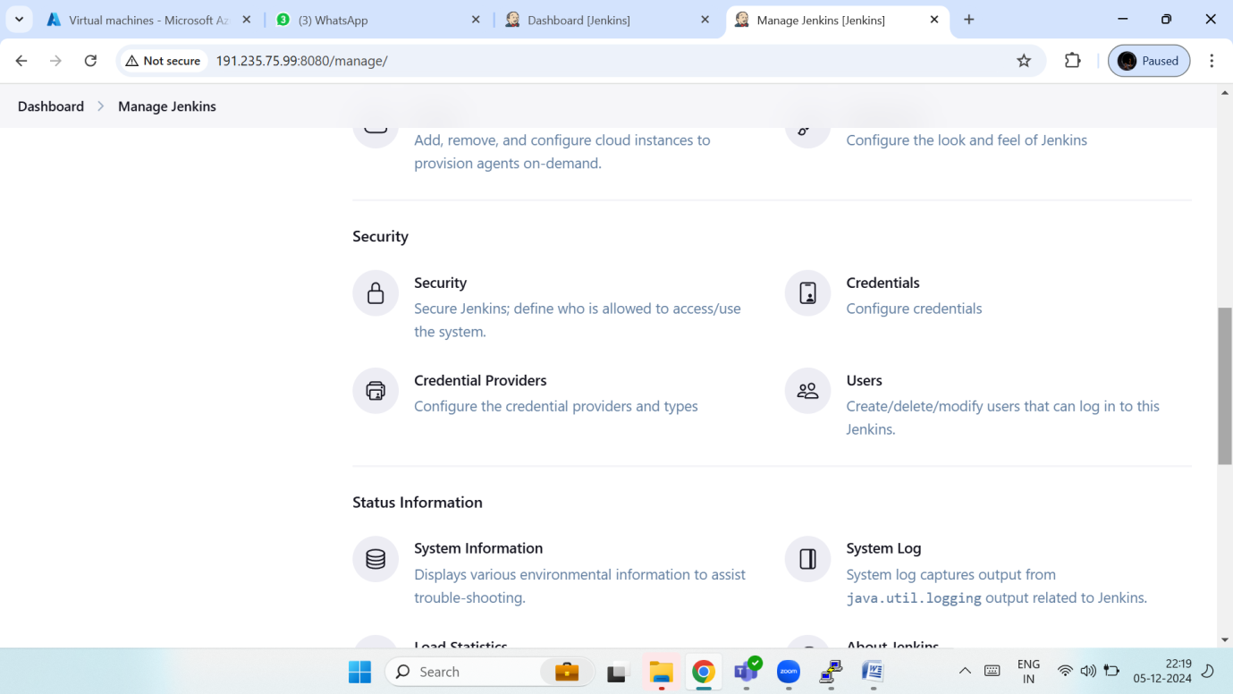
* Click on Users
* 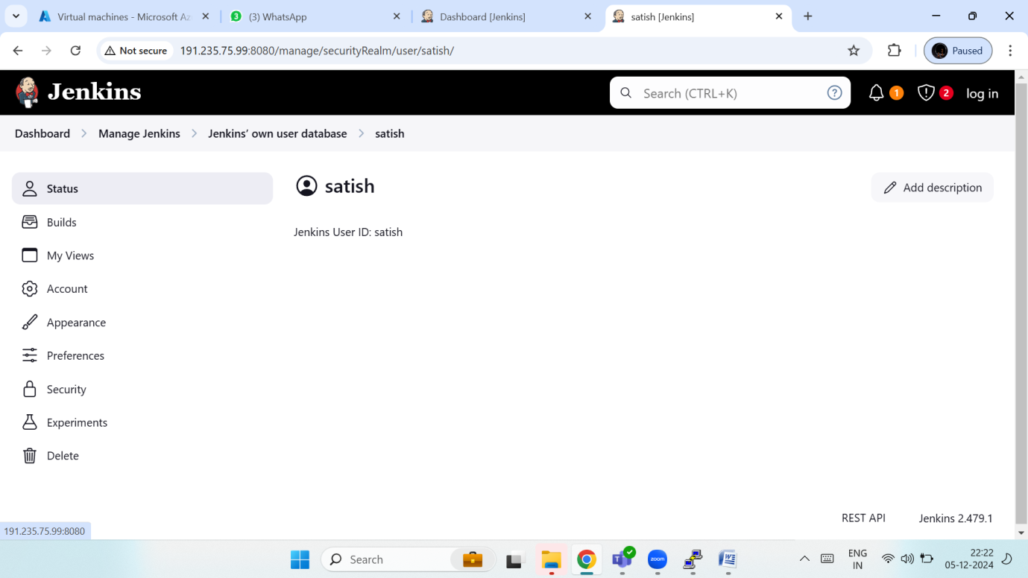
* Click on Security
* 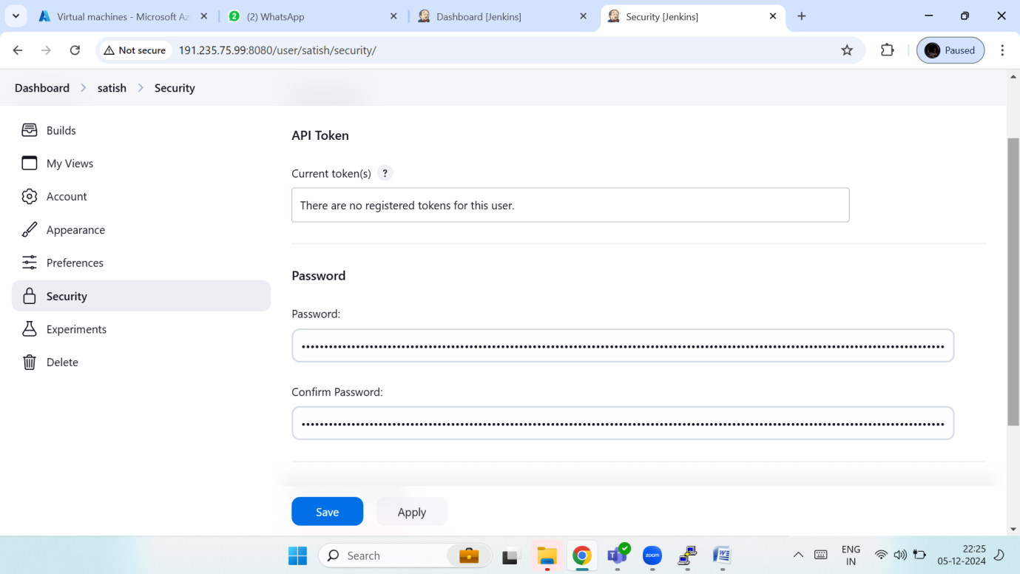
* Change Password
* Restart server and Login

How to import Jobs one Jenkins server another Jenkins server

* Go to Manage Jenkins
* Click Plugins
* Install import Job
* 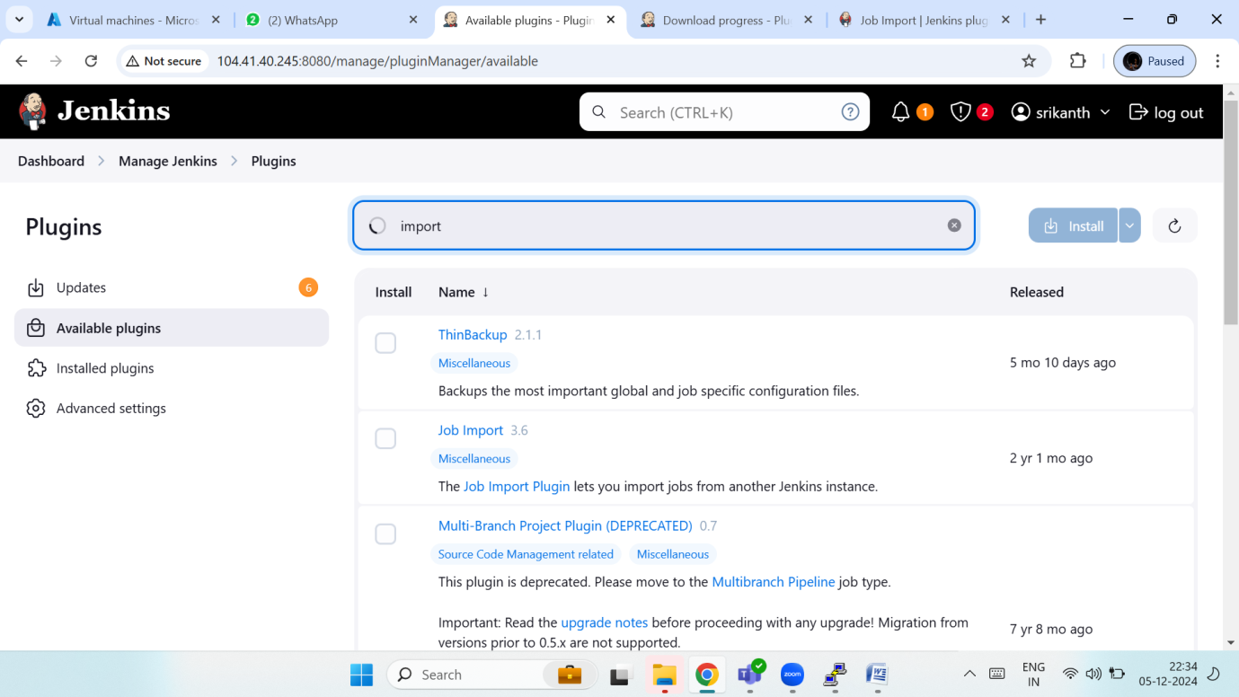
* Go to manage Jenkins
* Click on System configure
* Go to Import job Plugin …Configure the another Jenkins server Details
* 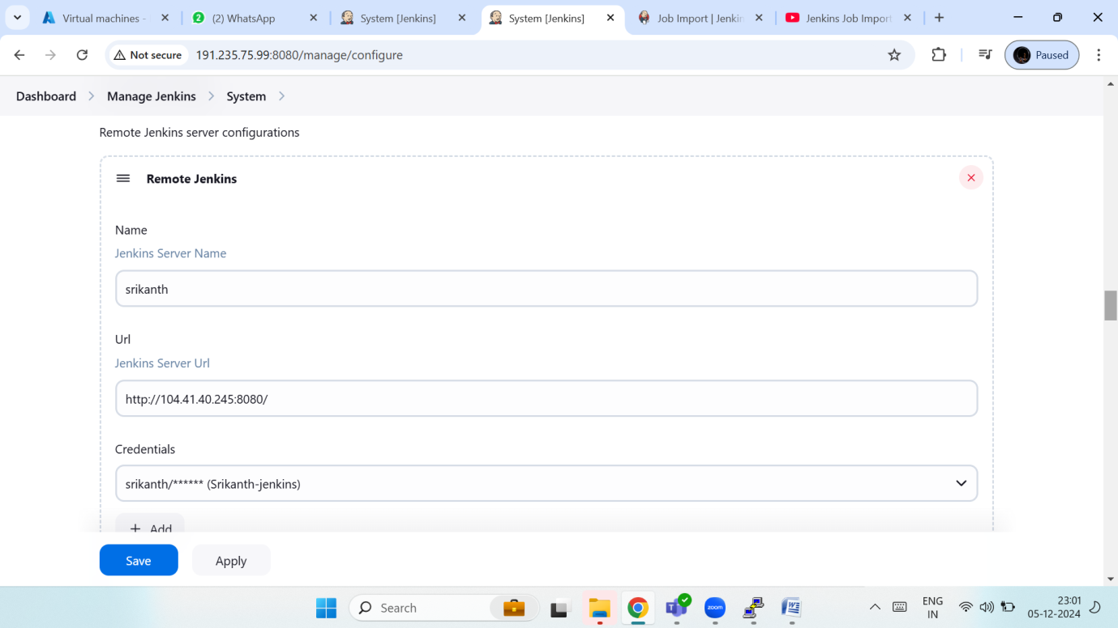
* Click save
* Go dash board Click on Import job
* 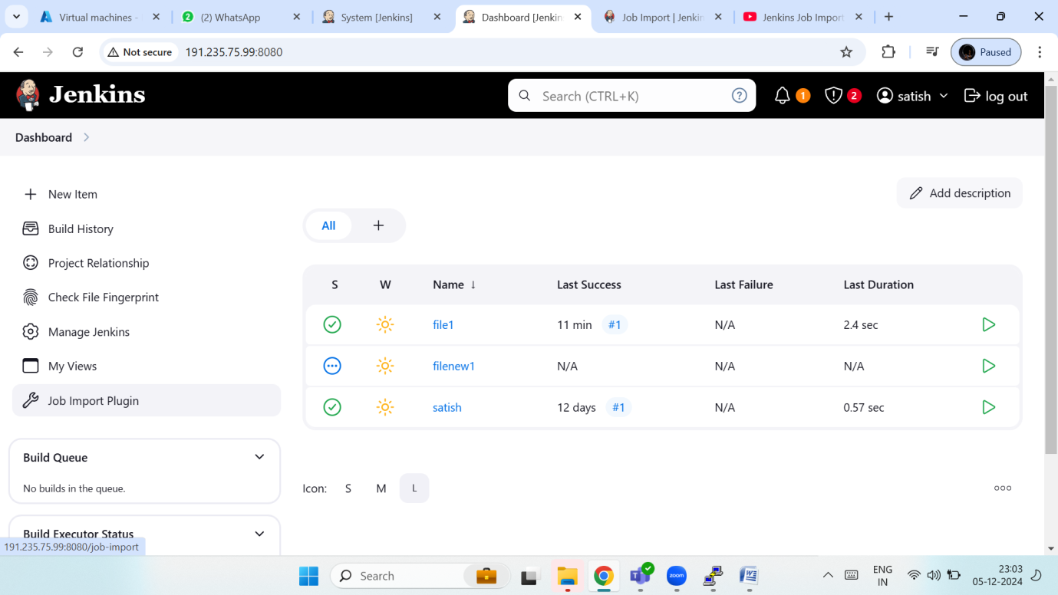
* Click on import job
* 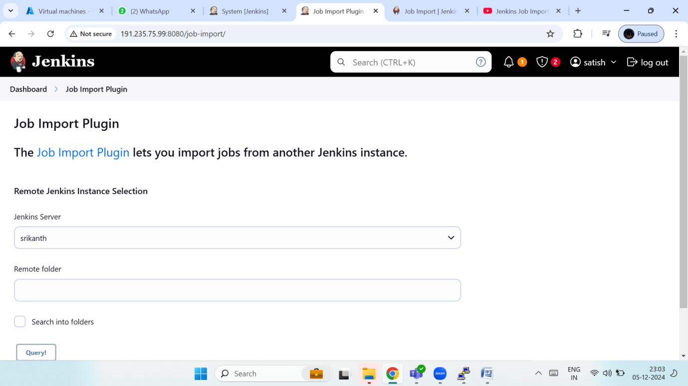
* Select the which job you import

